1. WAP to remove Duplicates from a String.

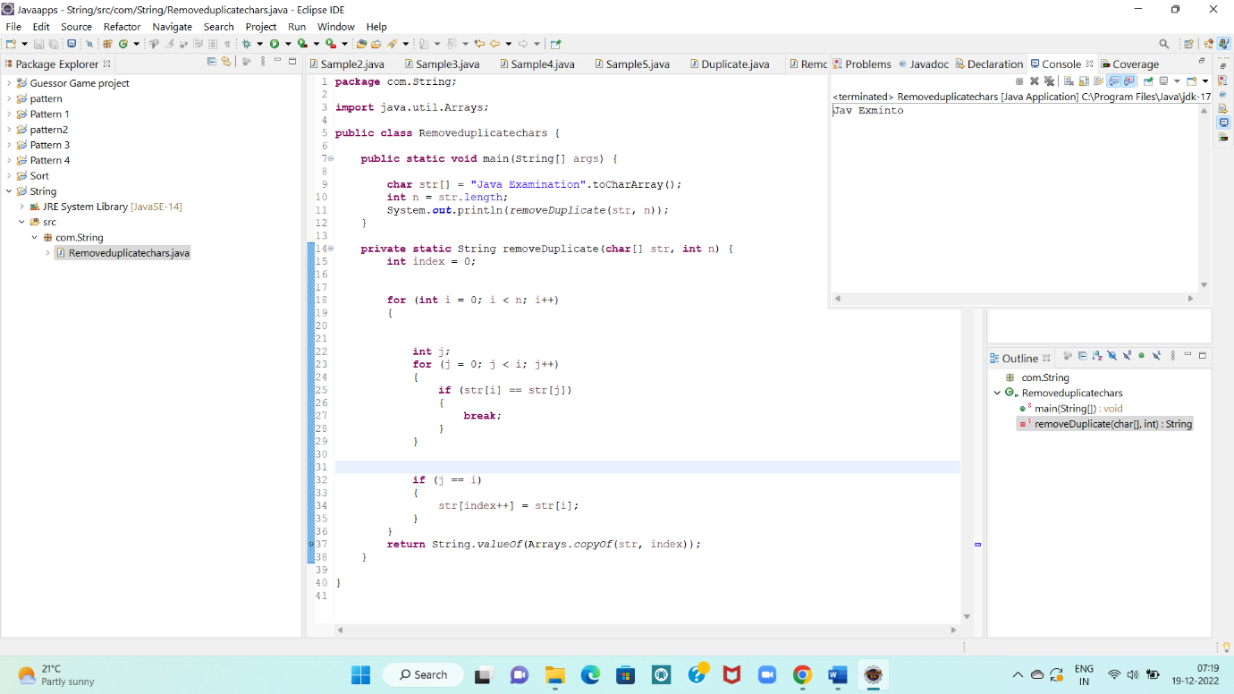

1. WAP to print Duplicates characters from the String.

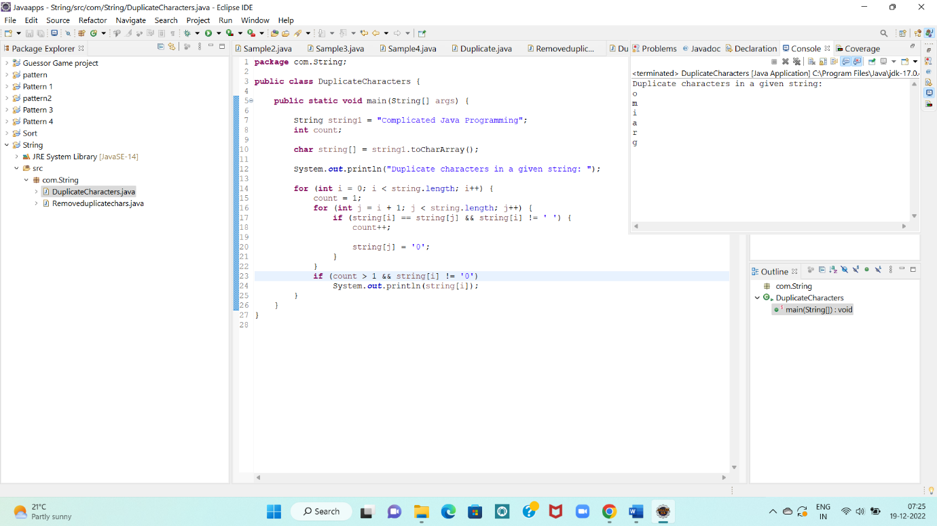

1. WAP to check if “2552” is palindrome or not.

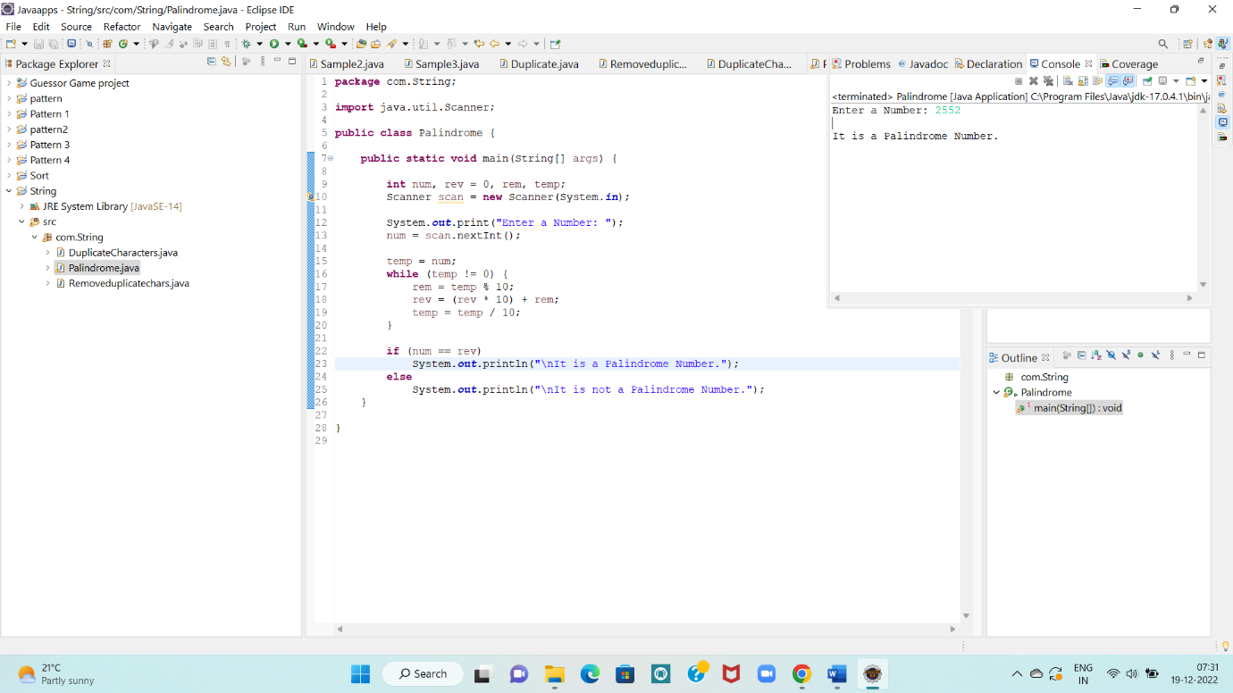

1. WAP to count the number of consonants, vowels, special characters in a String.

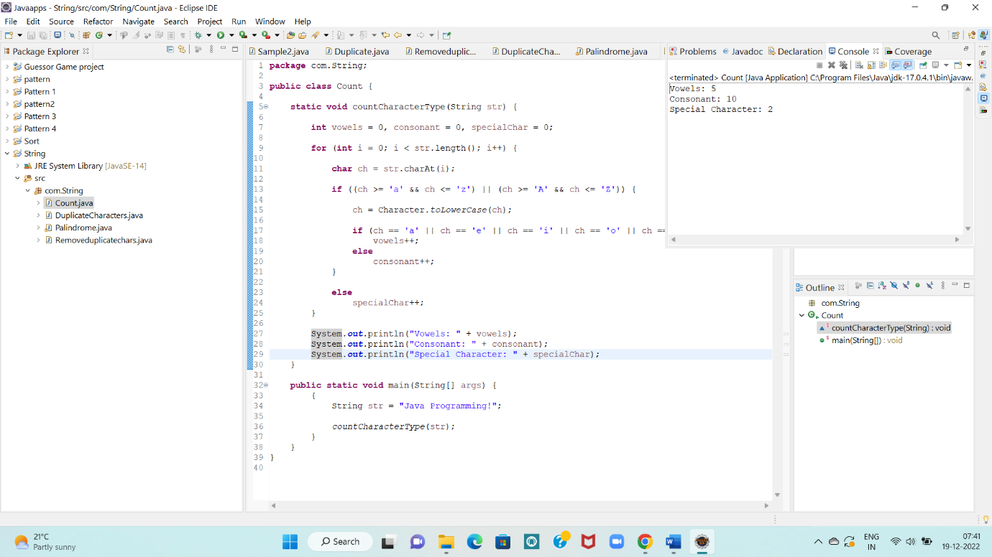

1. WAP to implement Anagram Checking least inbuilt methods being used.

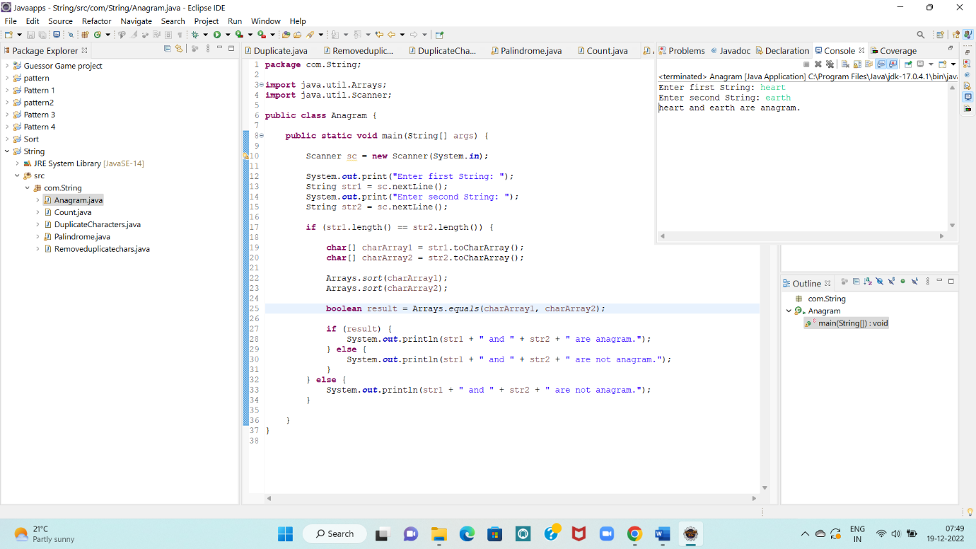

1. WAP to implement Pangram Checking with least inbuilt methods being used.

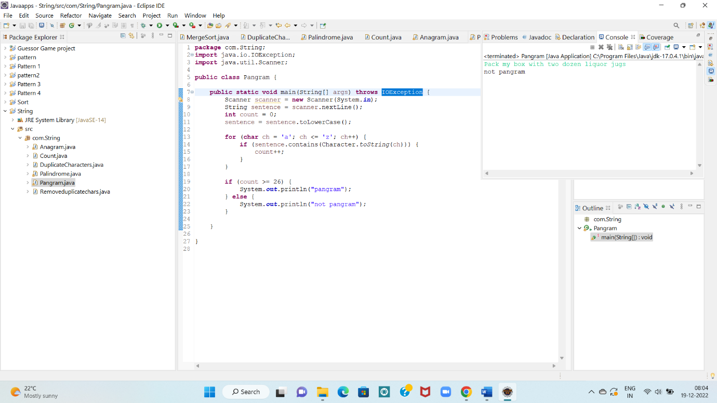

1. WAP to find if String contains all unique characters.

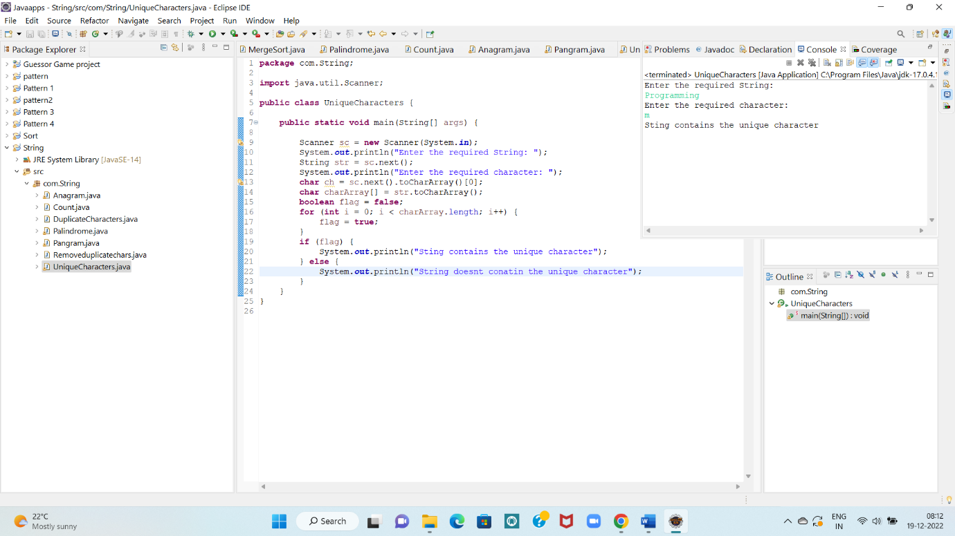

1. WAP to find the maximum occurring character in a String.

